Step 1 — Data Collection
- Collected credit card default dataset from UCI repository.
- Imported dataset into Jupyter Notebook.
- Saved raw dataset as Credit_card_dataset_raw.csv.
Output: Raw dataset for analysis.

Step 2 — Data Understanding
- Imported python libraries such as Pandas, Numpy ,Matplotlib and Seaborn
- Using functions such as Shape, Columns, info() , isna()
- Reviewed variable definitions and data types.
Purpose: Understand dataset quality and structure.

Step 3 — Data Cleaning & Preparation
Renamed columns for better readability.
Converted categorical variables:
- Gender
- Education
- Marital Status
Corrected inconsistent category values, Validated mappings using value counts.
Output: Cleaned and standardized dataset.

Step 4 — Feature Engineering
Created new analytical features:
- Education categories (default vs non-default groups)
- Credit limit segments
- Age brackets
- Credit utilization ratio
- Utilization risk segments
- Behavior indicators (repayment delay count)
- Monthly delay features
- Exposure risk metrics
Purpose: Convert raw data into business-relevant risk indicators.

Compared Default Rate across Education categories
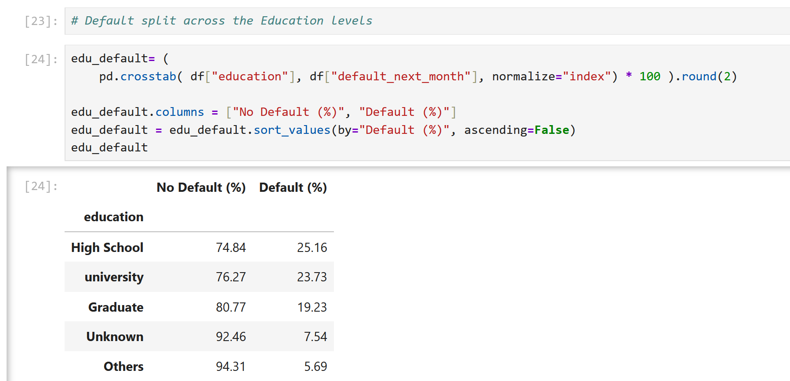

Step 5 — Credit Limit Risk Analysis
- Created credit limit brackets.
- Analyzed default rate across credit limit segments.
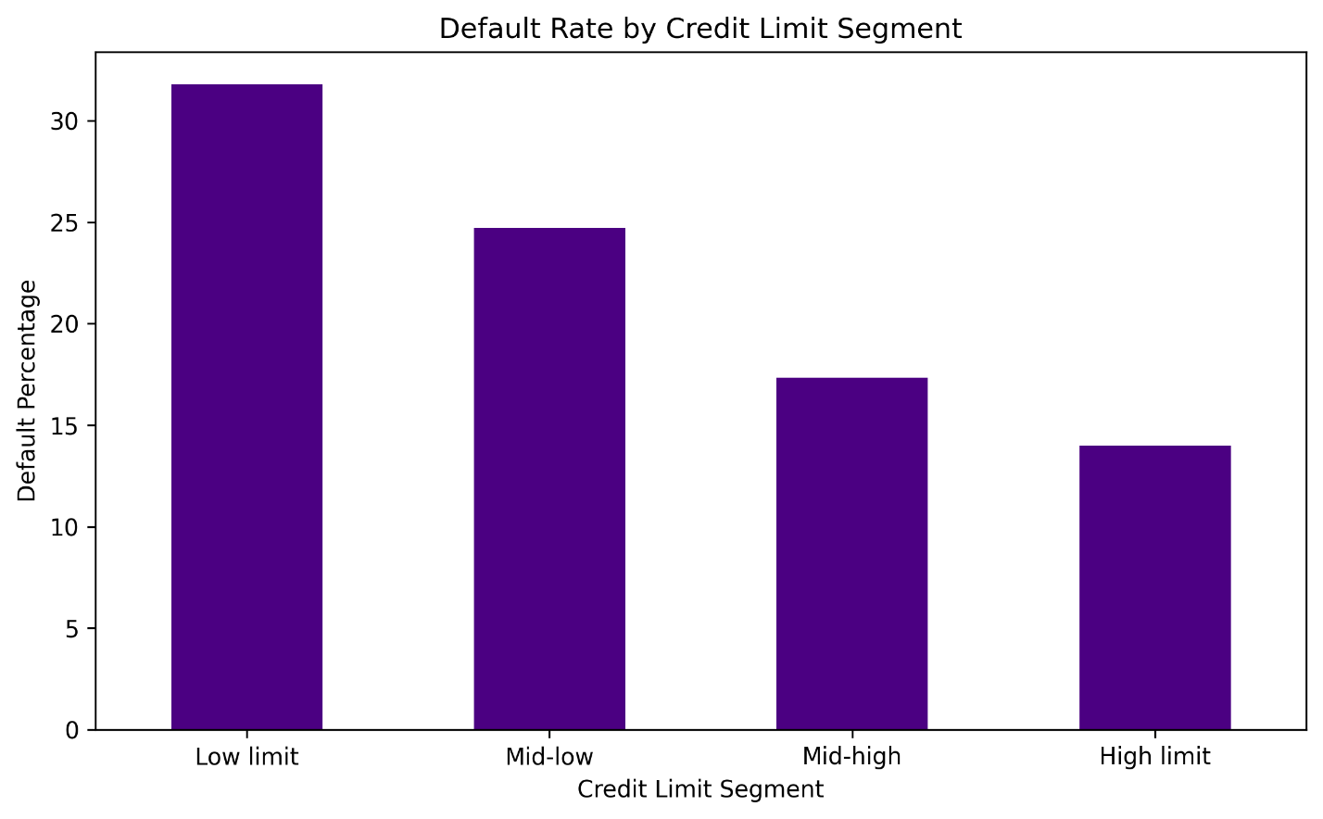

Step 6 — Age Risk Segmentation
- Created age bins.
- Calculated default rate per age group.
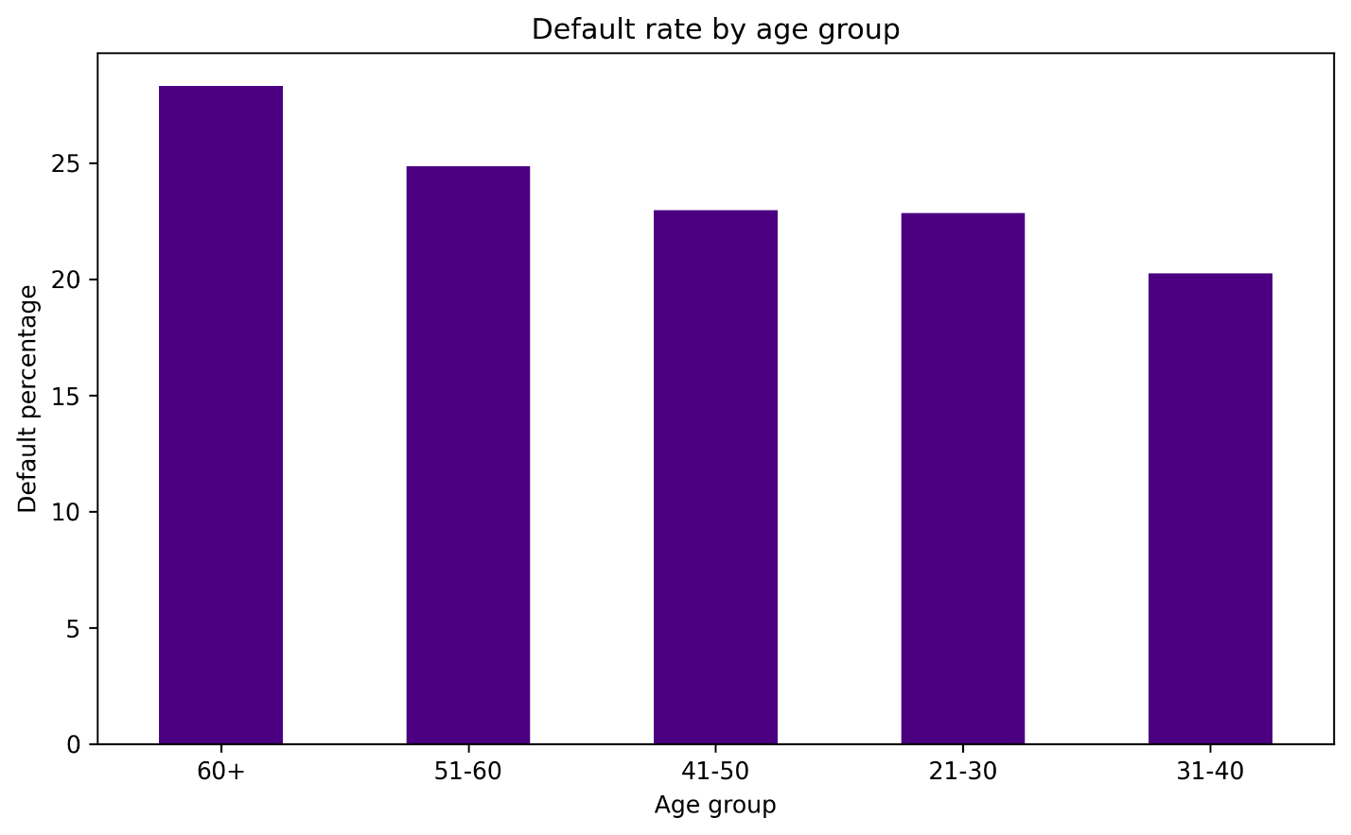

Step 7 — Behavior Risk Analysis
- Calculated total repayment delay months.
- Segmented customers by repayment behavior.
- Analyzed default rate by behavior segments.
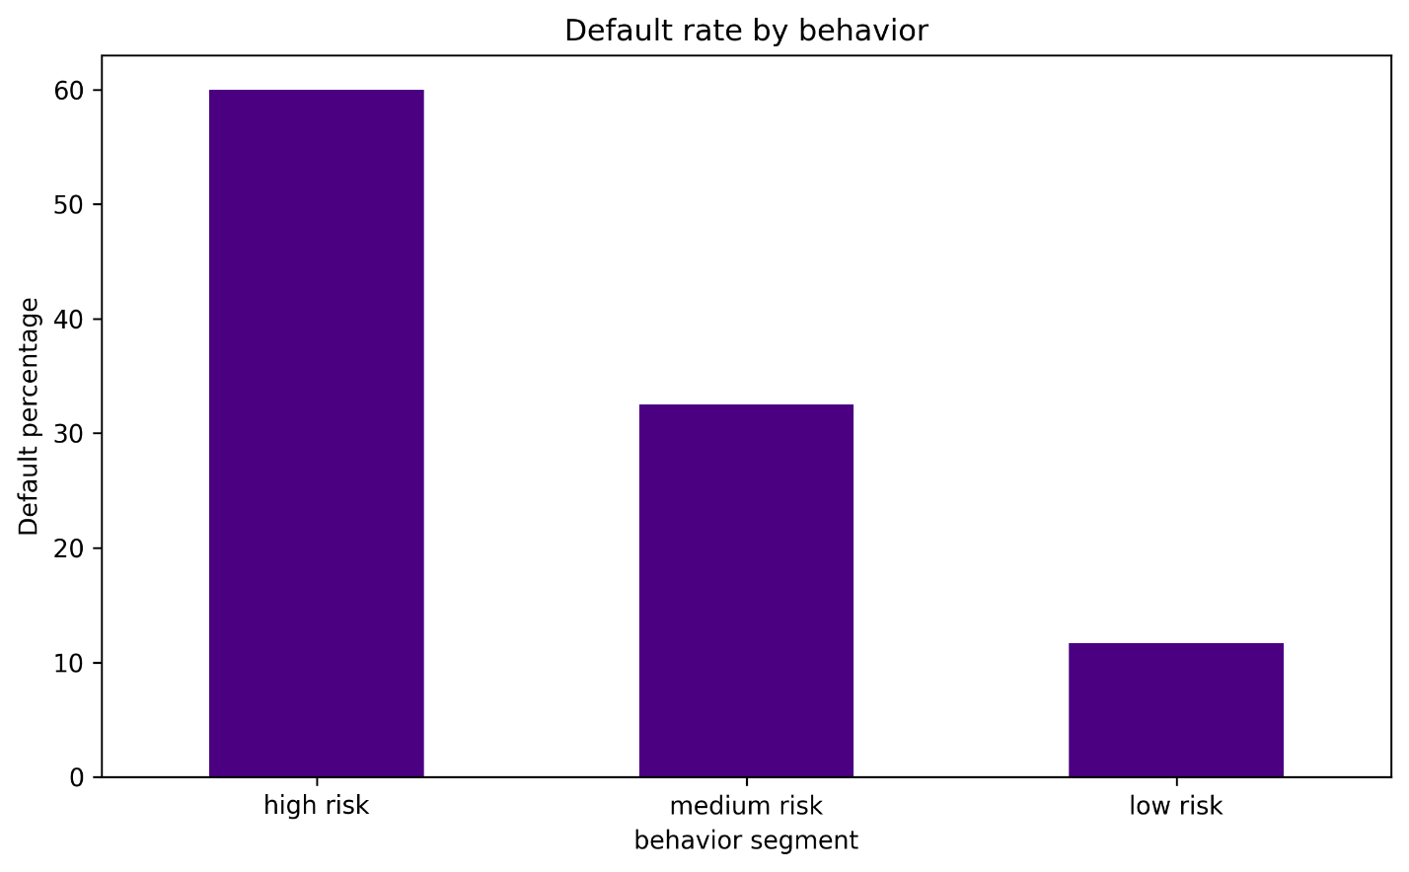

Step 8 — Credit Exposure Analysis
- Calculated total credit exposure per segment.
- Measured financial exposure risk.
- Analyzed contribution to total default by credit segment.

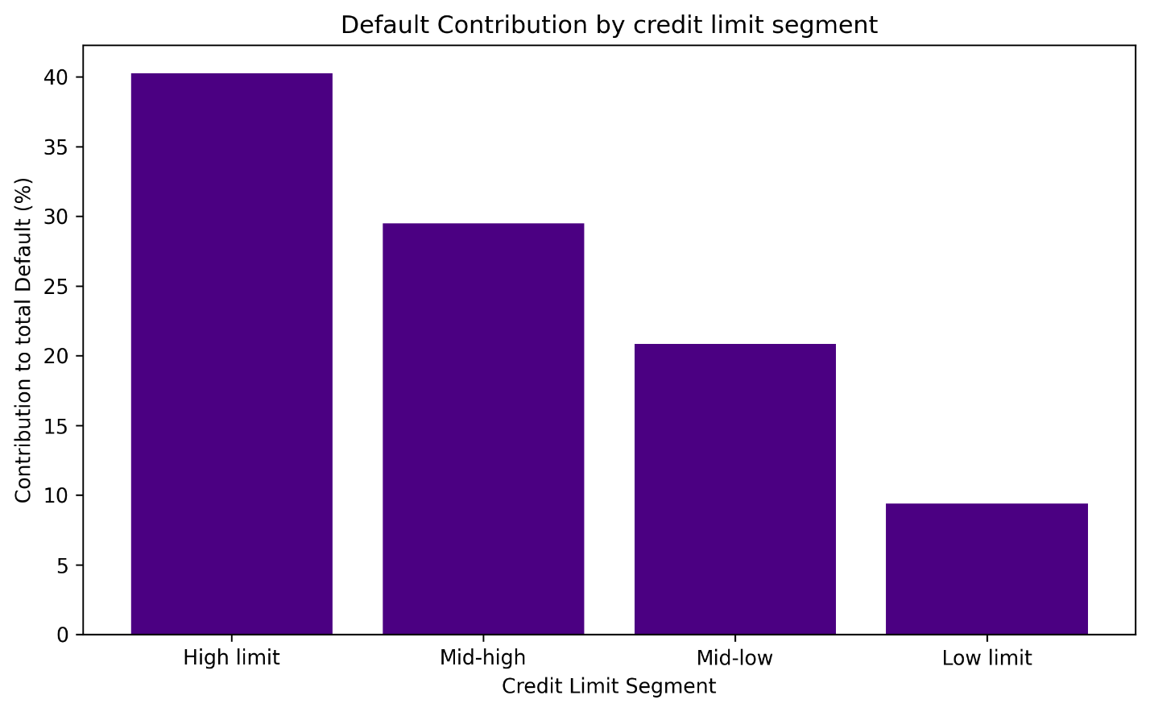

Step 9 — Credit Utilization Analysis
Calculated credit utilization ratio.
Created utilization risk segments.
Analyzed default behavior by utilization level.
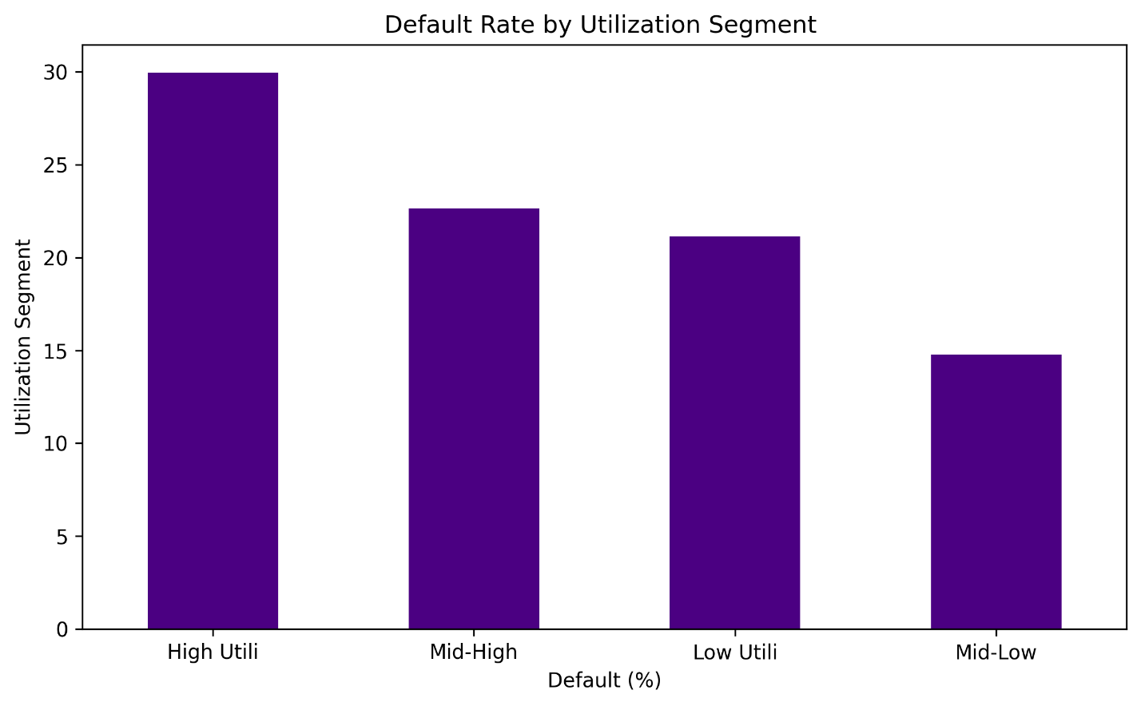

Step 10 —Payment Delay Default
- Calculated overall default rate by number of months payment was delayed.
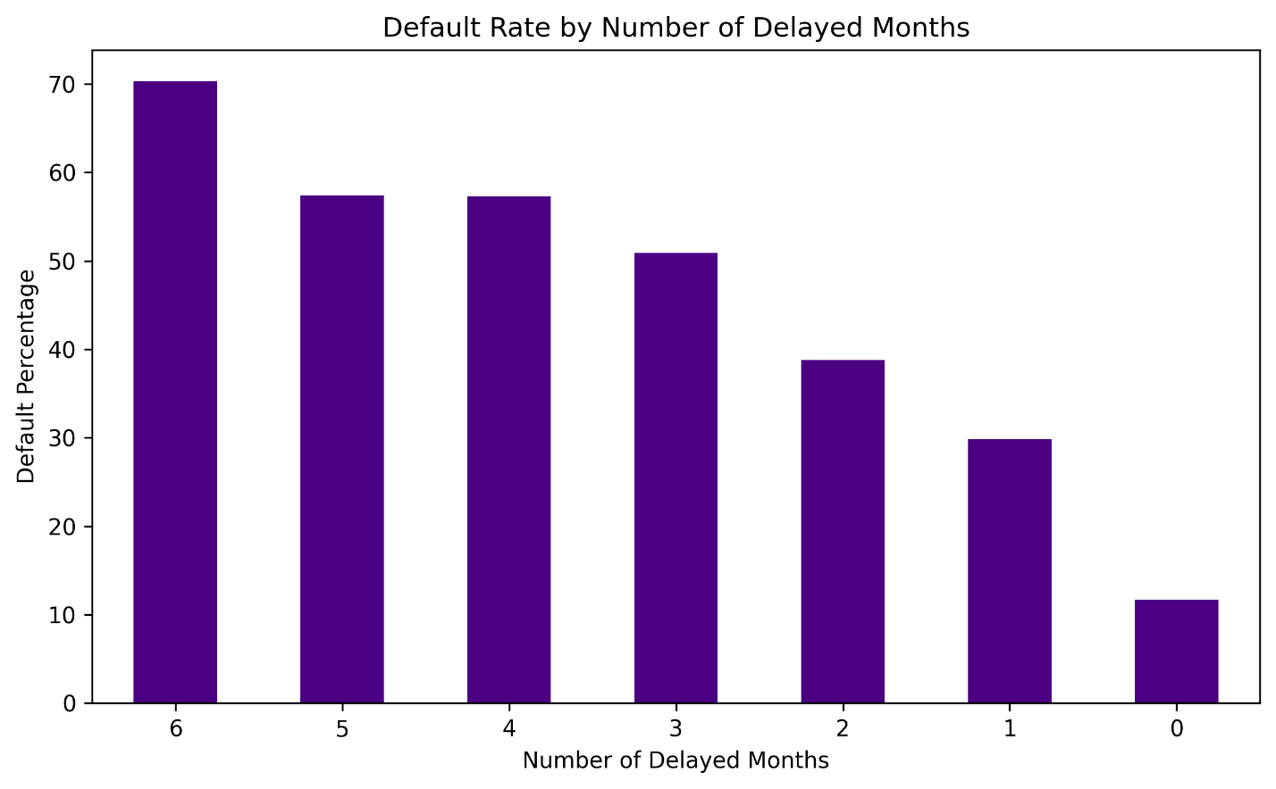

Step 11 — Correlation Validation
- Generated correlation heatmap to identify key predictors.
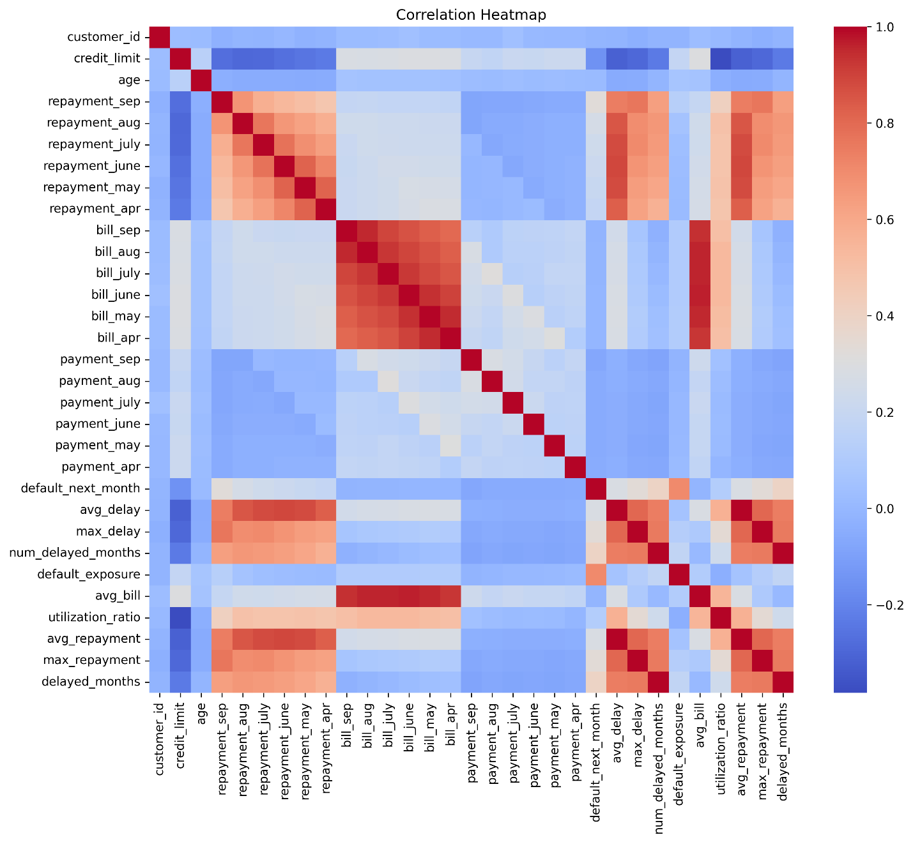
📊 Credit Risk Modeling

Step 12 — Data Preparation for Modeling
- Selected predictive features.
- Removed irrelevant variables.
- Split data into training and testing sets.
- Scaled numerical variables.

Purpose – Prepare Data for Predictive Modeling
Objective – Predict Probability of Customer Default to support decision-making

Step 13 — Logistic Regression Model
- Built logistic regression model to predict default probability.
- Generated predicted probabilities.
- Applied classification threshold.
Output: Default prediction model.

Step 14 — Model Evaluation
- Confusion matrix evaluation.
- Precision, recall, accuracy calculation.
- ROC curve analysis.
- AUC score evaluation.
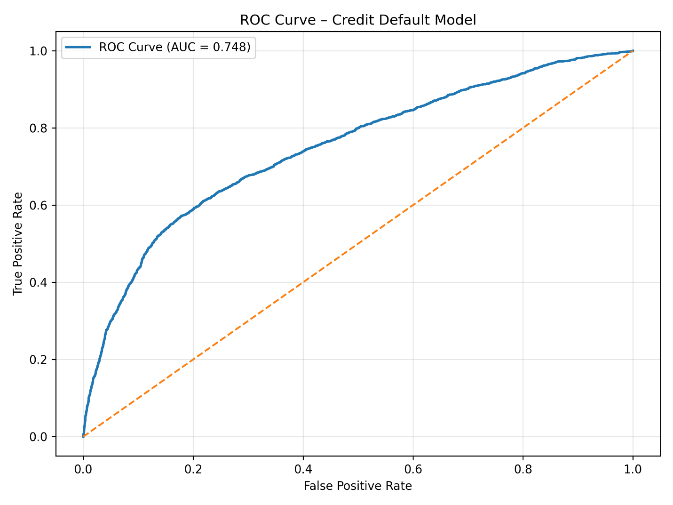

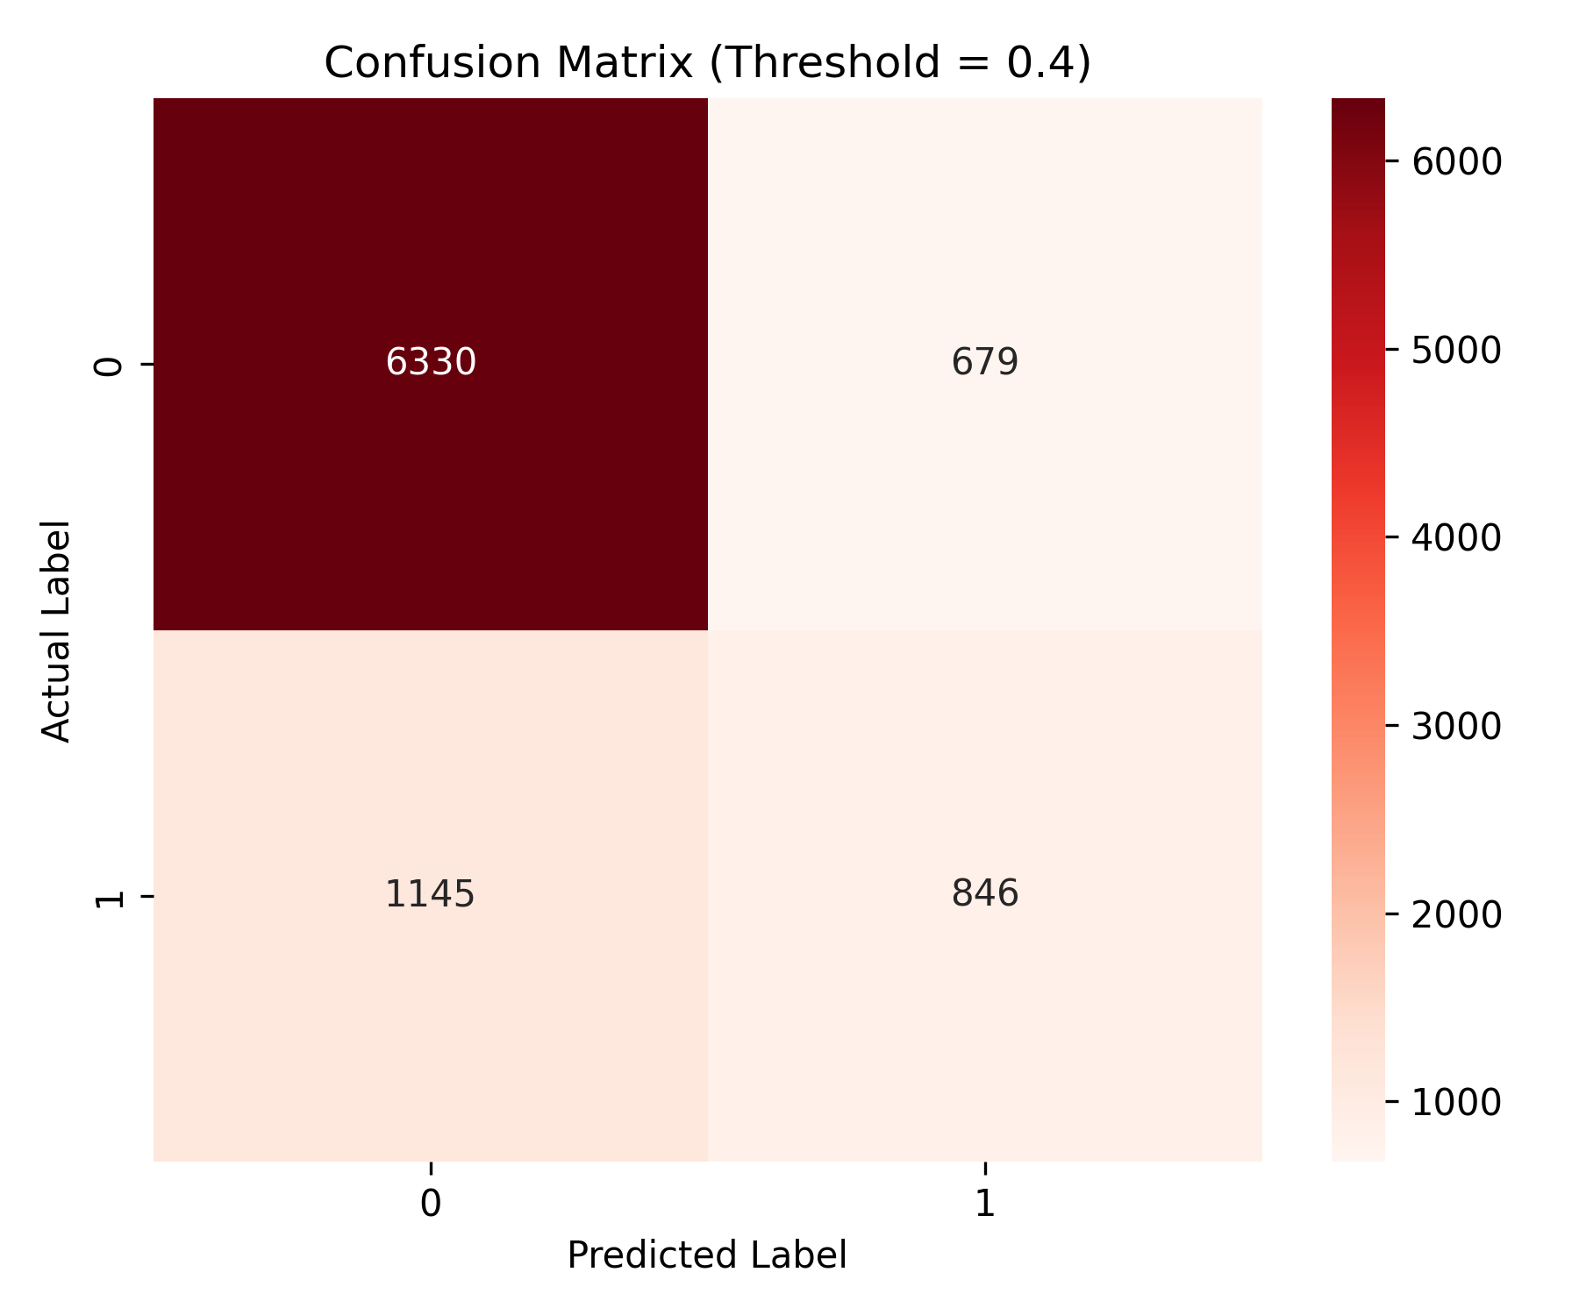

Step 15 — Threshold Optimization
Compared decision thresholds.
Selected cost-based optimal threshold = 0.3.

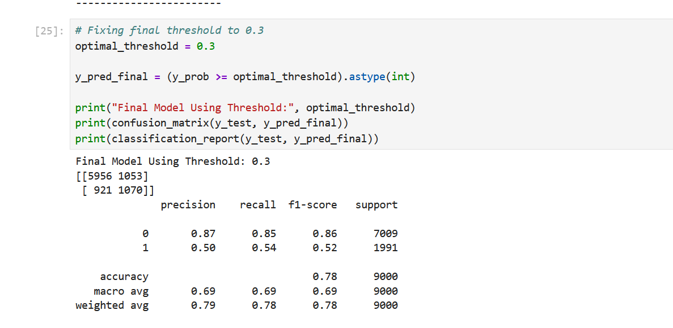
Result:
- Improved recall for defaulters.
- Estimated ~29% loss reduction vs default threshold.

Step 16 — Business Risk Interpretation
Identified key drivers of default:
- Repayment behavior
- Credit exposure
- Utilization
- Demographics
- Converted model results into business recommendations.

📈 Project Outputs
1. Credit Limit vs Default Rate
2. Age Group vs Default Rate
3. Behavior Segment vs Default Rate
4. Credit Exposure Analysis
5. Default Contribution by Segment
6. Utilization Risk Analysis
7. Default rate by number of months payment delayed
8. Correlation Heatmap
9. ROC Curve
10. Confusion Matrix

📊 Business Value Delivered
- Improved credit risk decision-making framework
- Identified high-risk customer segments
- Reduced financial exposure through predictive modeling
- Enabled proactive credit risk monitoring

